**Matlab Code:**

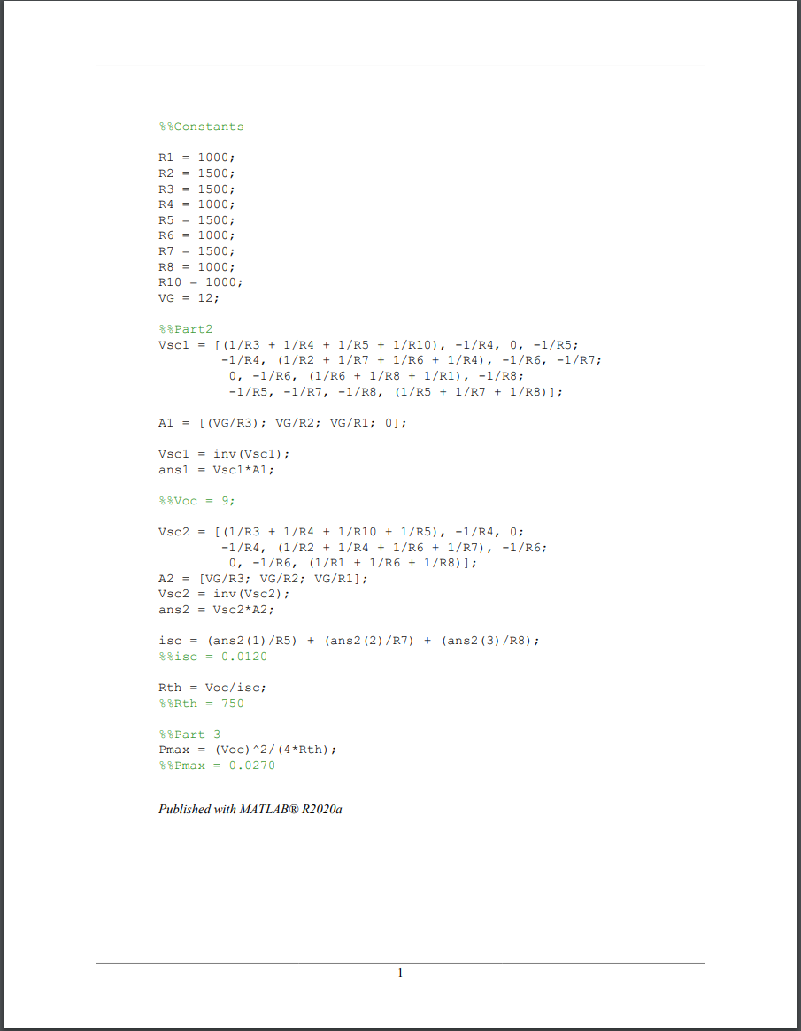

**Delta-Y Transformation/Thevenin circuit:**

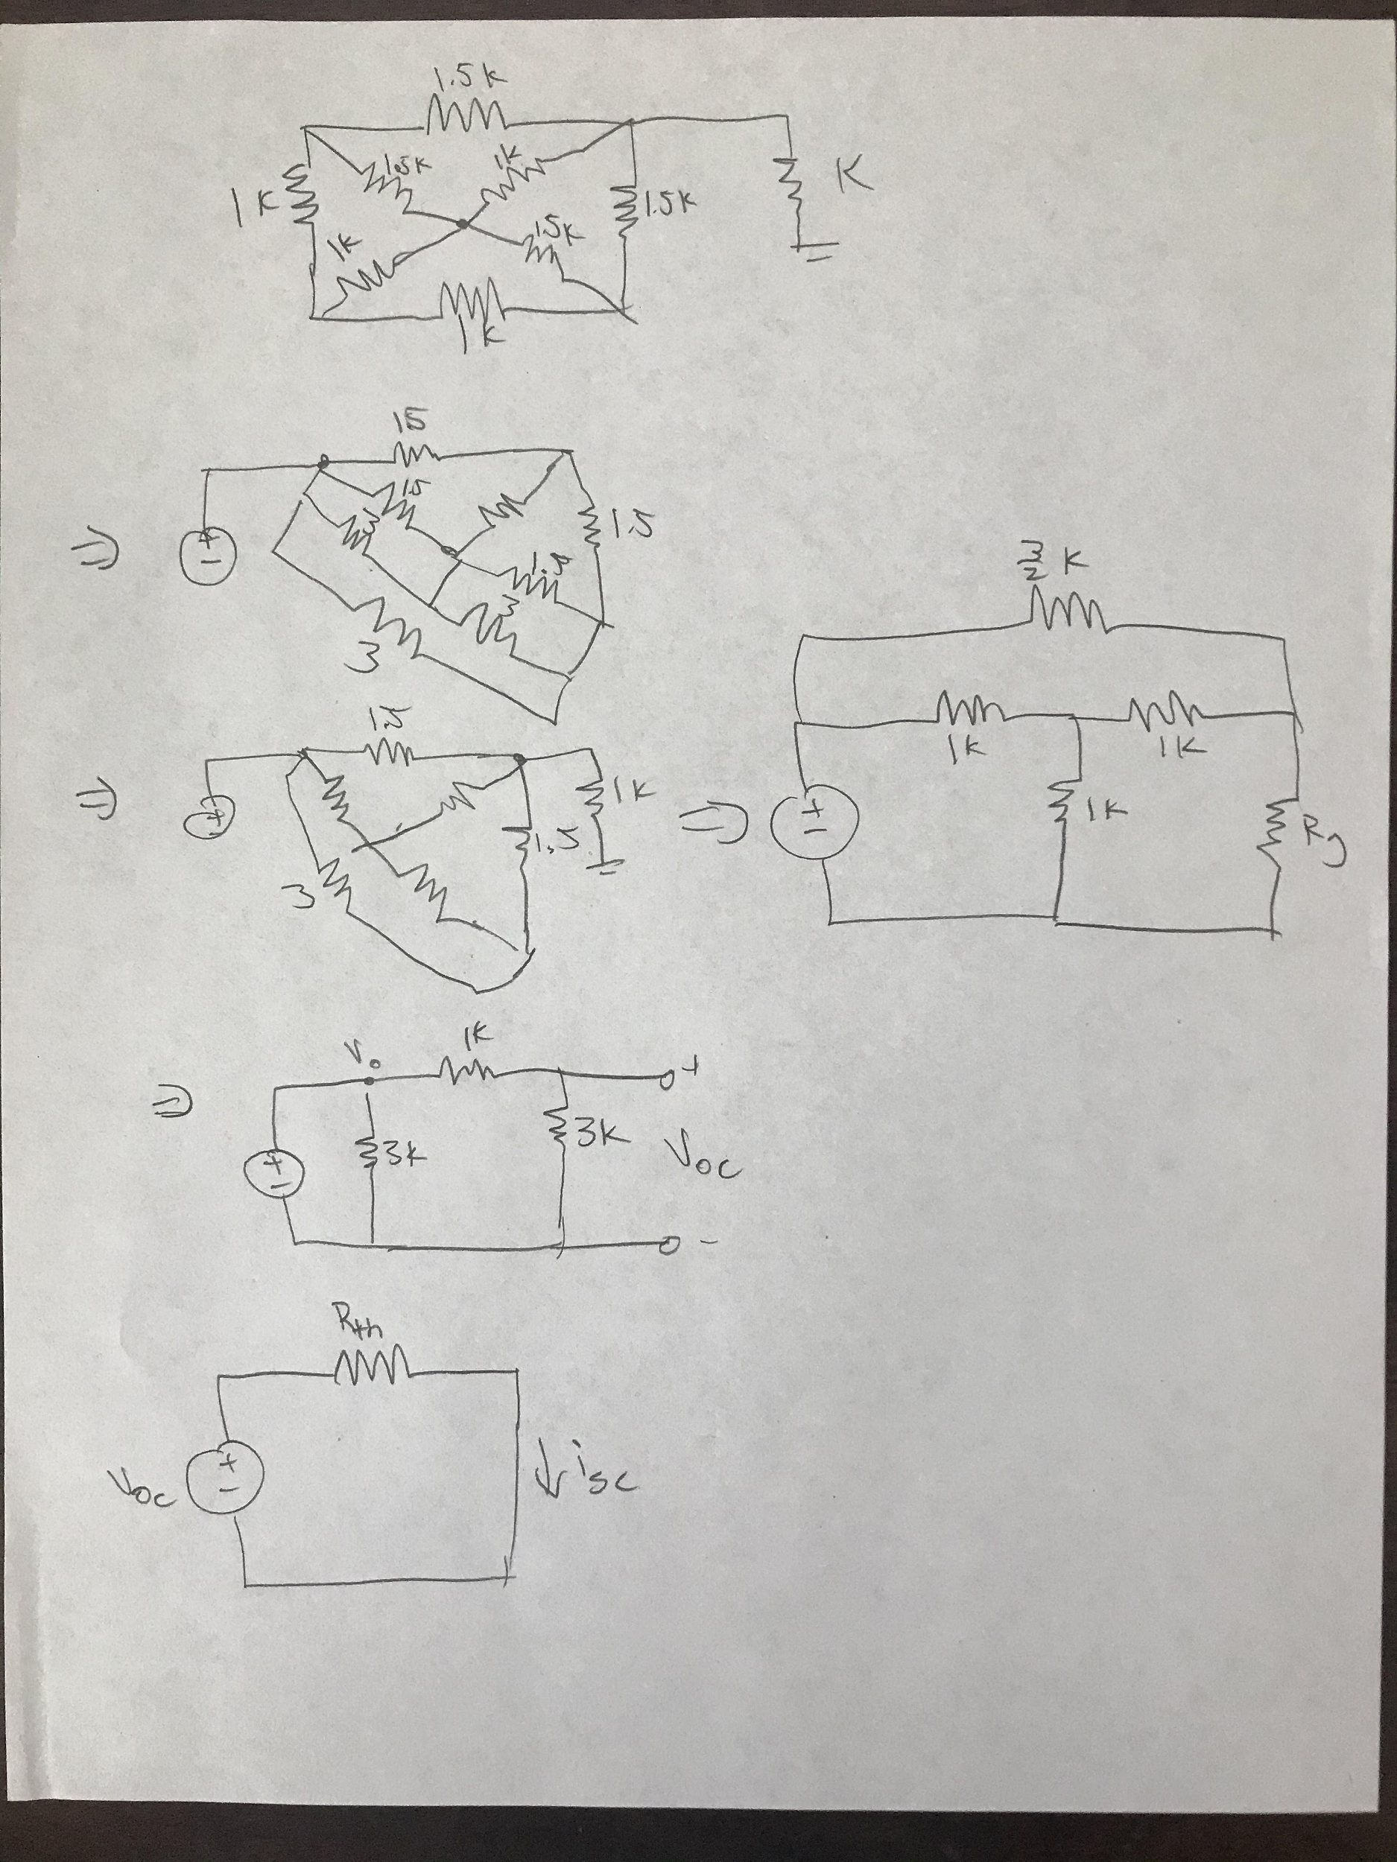

**Multisim Pictures:**

Voc:

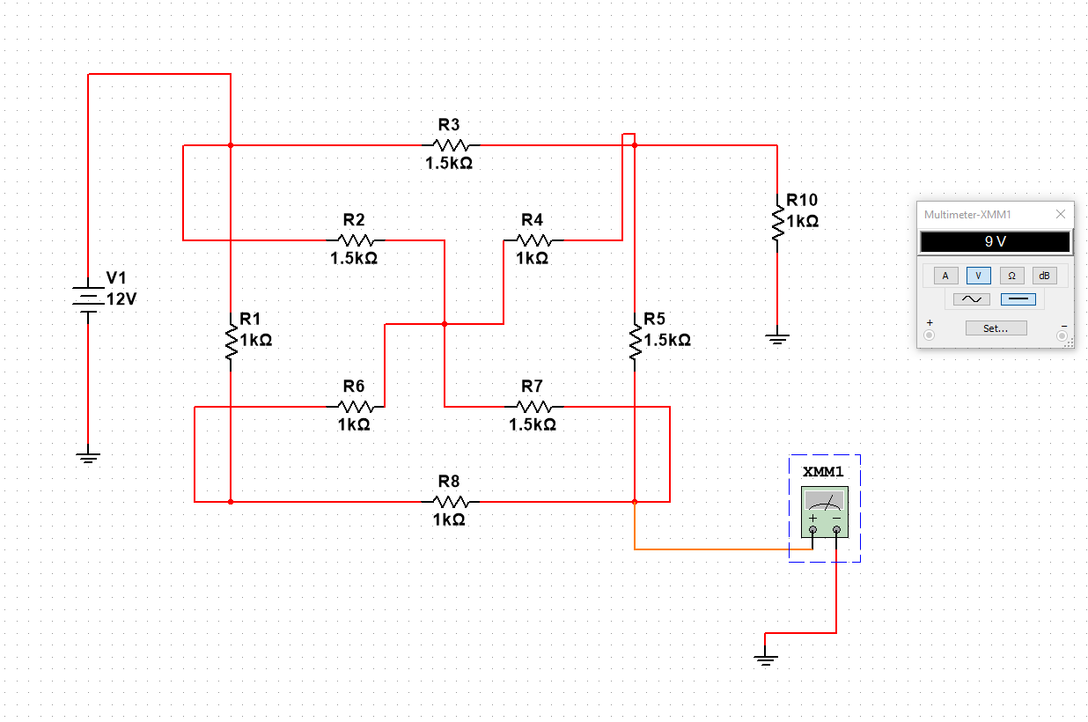

Isc:

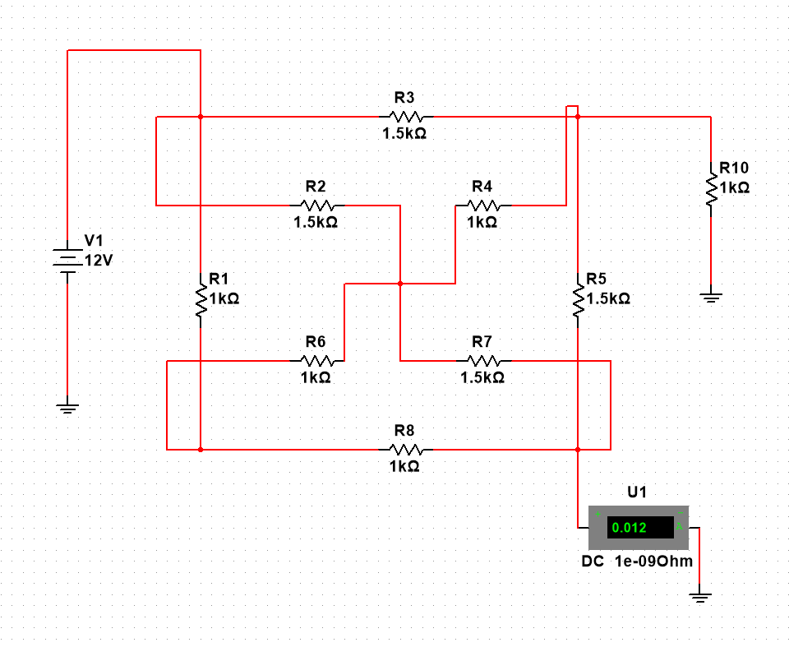

Rth:

